**YEAR 10 PHYSICS**

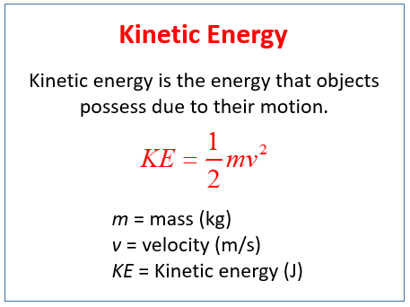KINETIC ENERGY CALCULATIONS

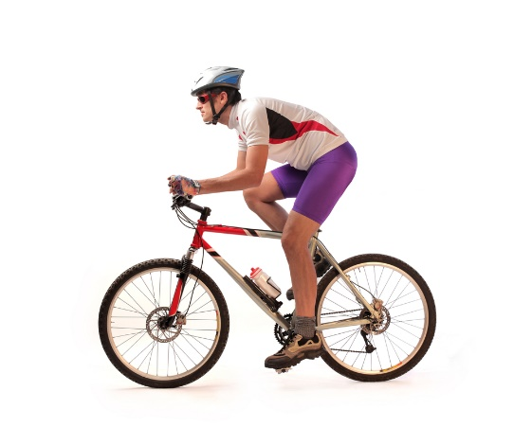



CALCULATE THE KINETIC ENERGY OF THE FOLLOWING OBJECTS AND SHOW YOUR WORKING OUT!!!!!!

1. A car is travelling with a speed of 40m/s and has a mass of 1120kg.

Mass = Speed = Kinetic energy =

2. You serve a volleyball with a mass of 2.1kg. The ball leaves your hand travelling 30m/s.

Mass = Speed = Kinetic energy =

3. A dolphin is swimming 20m/s and has a mass of 110kg.

Mass = Speed = Kinetic energy =



4. Your teacher is chasing their cat down the street, moving 5m/s and is 75kg.

Mass = Speed = Kinetic energy =

1. The two factors that determine the amount of kinetic energy an object has:

_______________ and _______________

1. Kinetic energy is measured in units of: _______________
2. Mass must be measured in units of: _______________
3. Velocity must be measured in units of: _______________
4. A shot putter throws a 7.26kg shot with a final velocity of 7.5m/s. What is the kinetic energy of the shot?
5. A bike rider approaches a hill with a speed of 8.5m/s. The total mass of the rider and the bike is 85kg. Find the kinetic energy of the bike and rider.

11. What is the kinetic energy of a ball with a mass of 5 kg rolling at 10 m/s?

12. What kinetic energy has a 2560kg car travelling at 15 m/s?

13. How much kinetic energy does a 5 gram bullet moving through the air at 100 m/s have?

14. Calculate the kinetic energy of a truck that has a mass of 2900 kg and is moving

at 55 m/s.

15. Calculate the kinetic energy a 12kg rock rolling down a hill with a velocity of 8 m/s.

REARRANGING THE KINETIC ENERGY FORMULA TO FIND

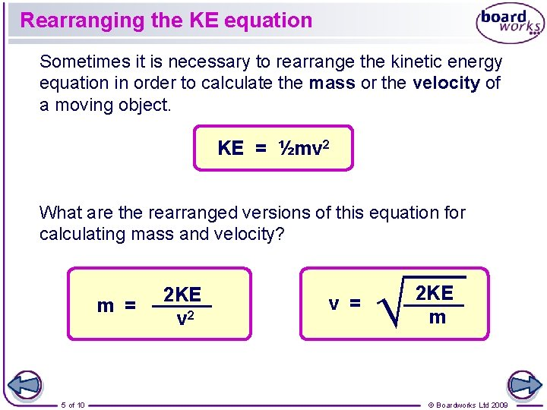MASS OR VELOCITY

16. Find the mass of a car that is travelling at a velocity of 60 m/s. The car has

5,040,000 J of kinetic energy.

17. What is the speed of a 110 kg woman running with a kinetic energy of 750 J?

18. What is the mass of a man running at 5.5 m/s if he has a kinetic energy of 2252 J?

19. What is the speed of a 5555 kg truck with a kinetic energy of 200639 J?

20. What is the mass of a car driving at 25 m/s if it has a kinetic energy of 200252 J?

TOTAL ENERGY

21. You are on roller blades on top of a small hill. Your gravitational potential energy is equal to 1,000 joules. The last time you checked your mass was 60 kilograms.

a. What is your kinetic energy when standing still at the top of the hill?

b. If you start skating down this hill, your potential energy will be converted to kinetic energy.

This is because of the Law of . This law states: “Energy be or .“

c. At the bottom of the hill, your kinetic energy will be equal to your potential energy at the top. What will be your **speed** at the bottom of the hill?

22. A frictionless roller coaster is shown below.

If its kinetic energy at **point A** is **8kJ** and its mass is 600 kg find:

1. Its total energy at **A**

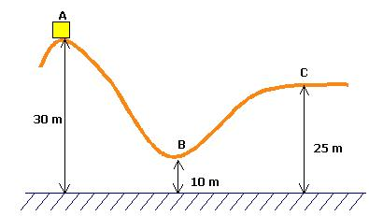

**45m**

**30m**

1. It’s total energy at **B**
2. It’s speed at **C**